Parallon
HCP Non-Privileged Practitioner (NPP) PAF Requirements
Version 5 – 06/2026

Credentialing Product Development

Contents
Summary / Business Problem 1
Assumptions 1
Requirements 2
User Interface (UI) 2
A. NPI Search Summary 2
B. Controlled “No NPI Available” Exception Workflow 3
ADD New Practitioner Card – Net New Practitioner 4
Verify Practitioner Information Card – Existing Practitioner 6
UI: ADD NPP to Facility PAF Action Option for MSP Roles 7
UI: ADD NPP to Facility PAF Type in PAF Tasks 8
Demographic Card 11
Manage Addresses Card (UI) 12
Primary Address (UI) 13
Manage Address 13
Add Address 14
Specialties Card 15
New Prompt for Unrecognized Specialties 16
Validation 16
Behavior 16
Cactus Updates – Specialties 16
Existing “Active” Practitioner 16
Net New or Inactive Practitioner 17
Building – ADD NPP to Facility Card 17
New Facility Card 18
Workflow 1 – VA = YES 18
Workflow 2 – VA = NO (Net New Providers) 19
Workflow 3 – Existing Practitioner 19
State License Requirements 19
Upload License PSV Requirements 20
Routing Rules 20
Cactus Updates – NPP Card – State License 21
Auto-Acceptance of ADD NPP 21
ADD NPP PAF Form & PDF Changes 21
Building – Cactus Records 22
Provider Record 22
Entity Assignment Record 22
Provider Address Record in Cactus Based on Data Entered on the PAF 23
Specialties 23
State License 24
NPI 24
Sanctions 25

Summary / Business Problem
CPC is seeking new PAF type of – ADD NPP to Facility.
CPC have been creating CVI’s for NPP scenarios that are outside of current scope. In certain circumstances the CPC is not responsible for the Non-Privileged Practitioner (NPP) process; I.E. Facility A does not have access or does not uses Meditech 5.x to register patients, NPP needs to be processed quicker than the 3-day time frame, or state law requires additional validations outside of current scope.
In this case Facility A would be responsible for performing the required verifications to support the undefined practitioner process (UDP) as opposed to the CPC. The MSP would then use the “ADD NPP” to Facility PAF as a mechanism to send primary source verifications (PSV) evidence of the required credentials to submit to the CPC to create or update the impacted record(s) in Cactus. In return the PSV will be added to the CACTUS database for the CPC to monitor applicable licenses and sanctions.

Assumptions
- The MSP User Roles will be the only HCP Roles that will submit NPP PAF Type work items.
- Submitters of the ADD NPP to Facility Type work items will understand the circumstances in which PAF selection is applicable.
- Will not be part of PAF Merging.
- Will not be part of packet determination rules or building packets.
- Credentialing Packets will not be created for ADD NPP to Facility PAF Type work items.
- CVIs will not be created for ADD NPP to Facility work items.
- Two branches of routing based on existing vs net new practitioner.
- Net New practitioner is a practitioner who currently does not reside in the CACTUS database.
- Existing “Active” Practitioner – Resides in CACTUS database with at least one active facility in which practitioner holds privileges.
- Existing “Inactive” Practitioner – Resides in CACTUS database with no active facilities.
- CPC routing of submitted ADD NPP PAF Type work items will follow the same path and logic that the Add Practitioner to Facility PAF Type work item follows.
- The CPC will not be performing any credentialing verifications on the ADD NPP practitioners.
- Open and Completed Queue Considerations: Ideally will be able to filter by PAF Type, ADD NPP, if this is the best design approach.
- Audit Logs will be generated for all system updates.
- Duplicate checks will be ran against existing records in CACTUS to avoid duplication.
- PAF will be auto accepted.

Requirements

User Interface (UI)
Practitioner Search
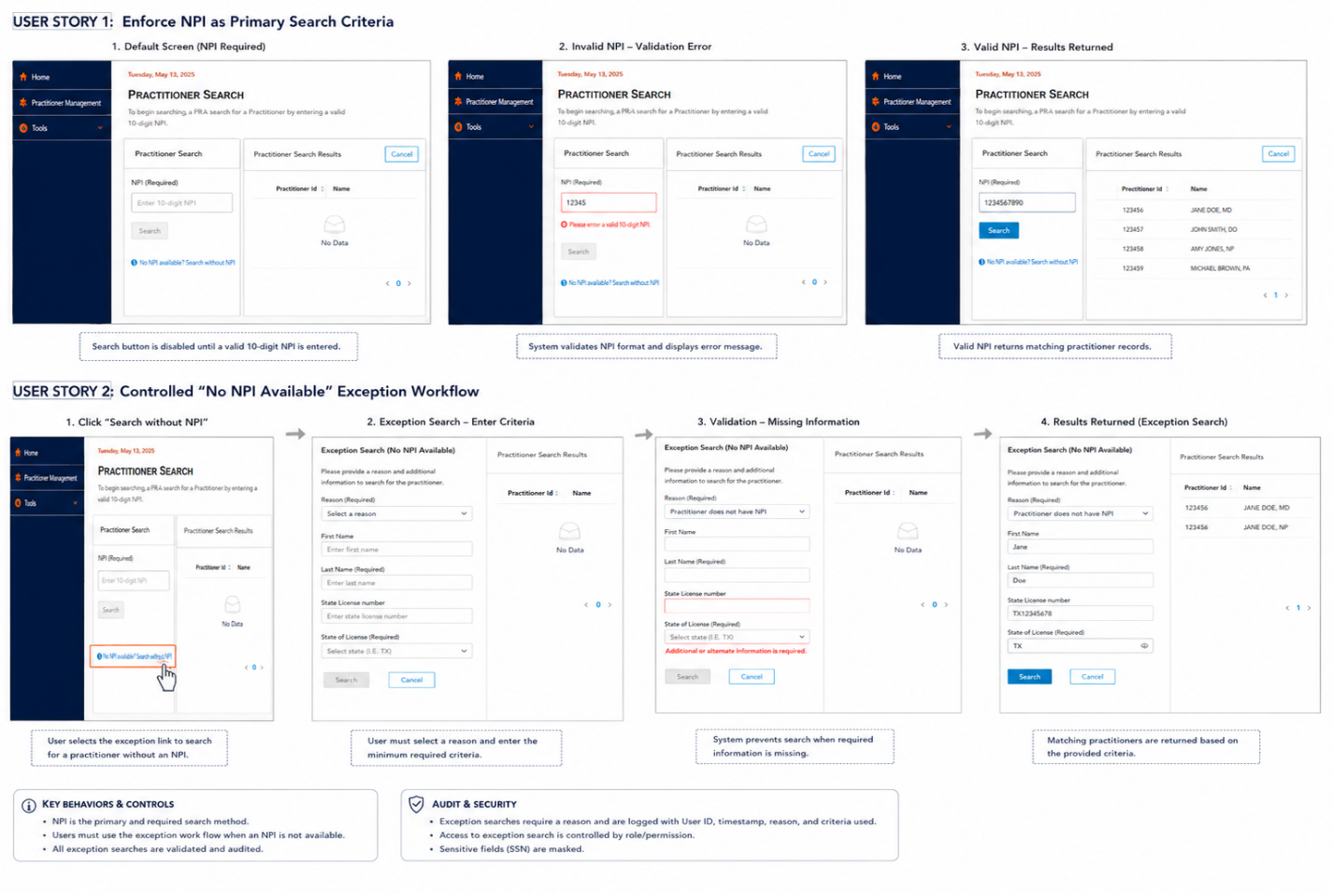
UI: ADD NPP to Facility PAF Practitioner Search – Add New Practitioner

NPI Search Summary
Practitioner Search – NPI Required Workflow
Summary
The Practitioner Search workflow within HCP enforces NPI as the primary and required search criteria. Users must enter a valid 10-digit NPI before initiating a standard practitioner search. A controlled exception workflow is available when an NPI is unavailable.
The workflow includes:
- Enforcement of NPI as the primary search method.
- Validation of NPI format.
- Controlled exception workflow for practitioners without an NPI.
- Required minimum search criteria for exception searches.
- Audit logging of all exception searches.
Enforce NPI as Primary Search Criteria (Same as other PAF types)

Controlled “No NPI Available” Exception Workflow
Summary
Users must use the exception workflow when a practitioner NPI is unavailable.
Selecting the “No NPI available? Search without NPI” link routes the user to the Exception Search workflow.
Requirements
Exception Search Fields
- Reason (Required)
- Dropdown values include:
- Practitioner does not have NPI
- Last Name (Required)
- Validation message: Minimum 2 alpha characters required.
- First Name (Required)
- Validation message: Must be a minimum of 1 alpha characters.
- State License Number
- Supports alphanumeric characters and special characters.
- During HCP-to-VC lookup, special characters may be removed/ignored to support normalized matching or vice versa.
- Lookup should support “like” comparisons rather than requiring an exact character-for-character match.
- Validation message: Minimum of two characters is required.
- State of License (Required)
- Source: LOOKUP_STATE.
- Use the same state lookup method currently implemented across HCP for state selection/search functionality.
Validation Rules
The Search CTA button remains disabled until:
- Reason is selected.
- First name contains at least one alpha character.
- Last Name contains at least 2 alpha characters.
- State of License is selected.
- State License Number is entered and contains a minimum of two characters.
Action Buttons
- Search
- Executes exception practitioner search.
- Cancel
- Returns user to Practitioner Search screen.

ADD New Practitioner Card – Net New Practitioner
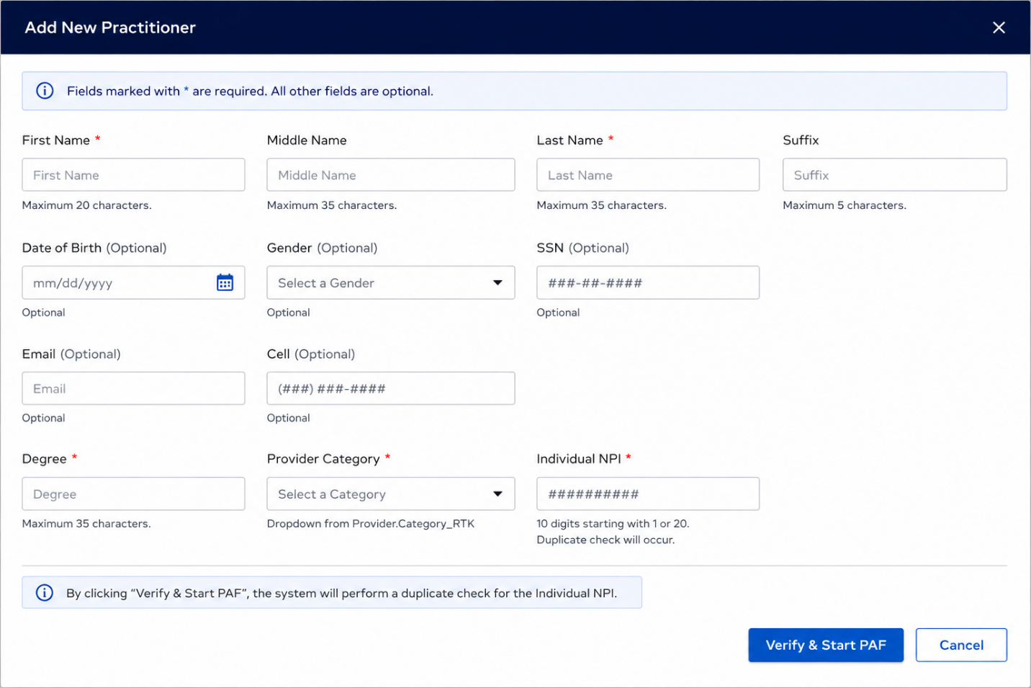
Existing functionality will remain as is with the following exceptions for “ADD NEW PRACTITIONER”:
The following fields will be optional for completion:
- Email
- Cell
- DOB/SSN
- Gender
User must complete the following information fields:
Field | Requirement
First Name | Required, Character 20
Last Name | Required, Character 35
Suffix | Not Required, Character 5
Degree | Required, Character 35
Provider Category | Required, Dropdown from Provider.Category_RTK
Individual NPI | Required, 10 digits starting with 1 or 20, Duplicate check will occur.

Verify Practitioner Information Card – Existing Practitioner
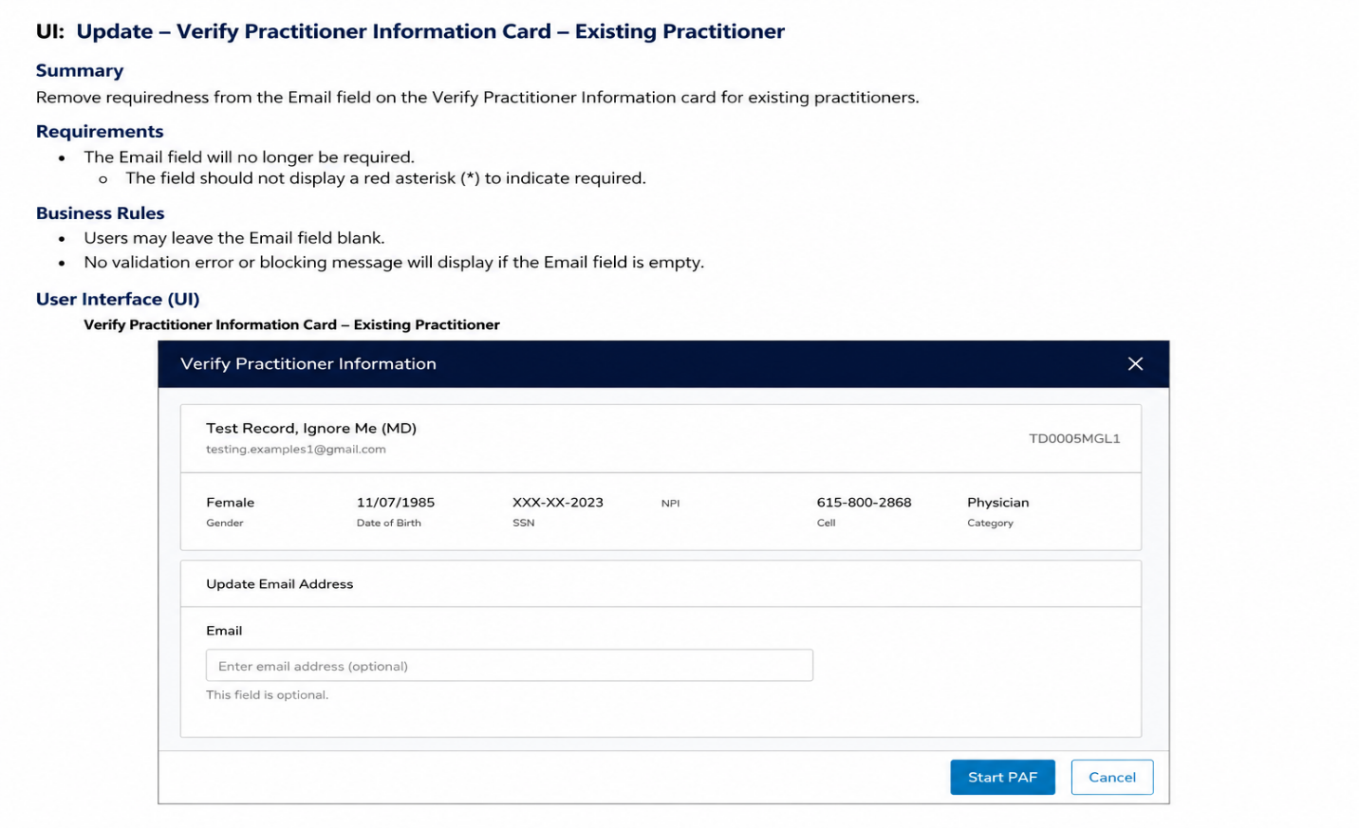
Summary
For Existing Practitioner workflows within the Verify Practitioner Information Card, the Email field will remain optional for completion. However, if an email address already exists within the field, the user will not be permitted to edit or update the value.
Existing practitioners may already reside within CACTUS and associated downstream systems with previously validated demographic information. In these scenarios, MSP users should not be permitted to modify an existing email address from the Verify Practitioner Information Card.
If no email address exists, the field will remain editable and optional for user completion.
Requirements
- The “Update Email Address” section will remain visible for Existing Practitioners.
- The Email field will no longer be required.
- Remove the required field indicator (*) from the Email label.
- If an email address already exists within the Email field:
- Display the existing email address as read-only.
- User will not be permitted to edit, overwrite, or remove the value.
- Field will display in disabled/read-only state.
- If the Email field is blank:
- Field will remain editable
- User may enter an email address.
- Completion of the field remains optional.
- Validation rules for email formatting will remain in place only when a value is entered.
- If the Email field is blank:
- No validation error will display.
- User may proceed with selecting “Start PAF.”
- Existing functionality for New Practitioners will remain unchanged unless otherwise specified.

UI: ADD NPP to Facility PAF Action Option for MSP Roles
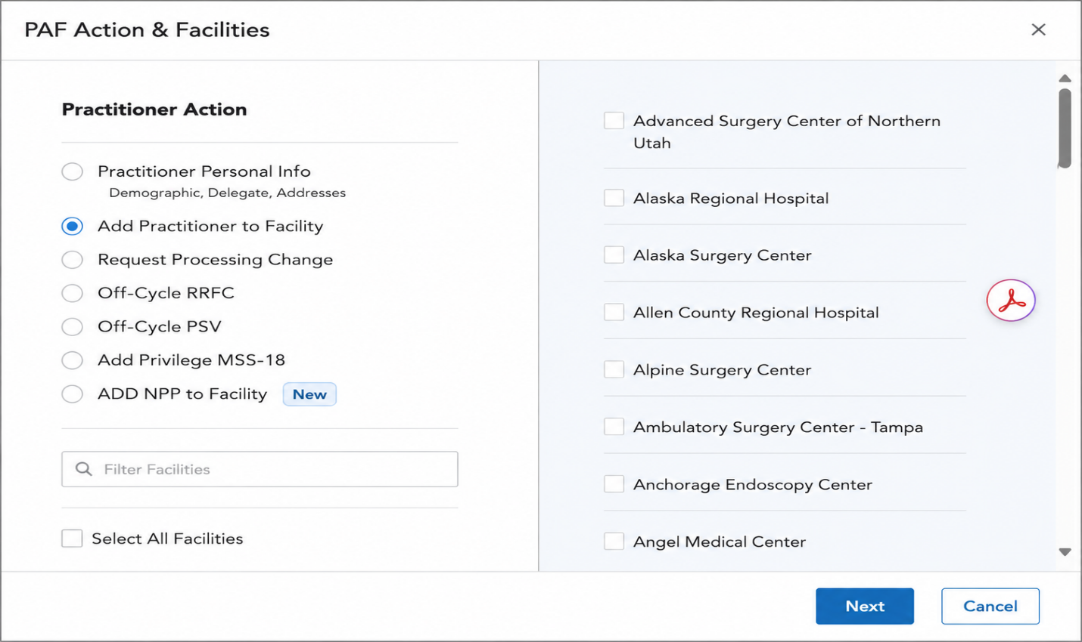
Requirements
- A new PAF Action radio button labeled “ADD NPP to Facility” will be created specifically for the MSP User Role.
- This option will only be accessible if the practitioner is either a net new practitioner or an existing practitioner currently inactive with the entity.
- The same criteria as outlined in the PAF Task determination rules for both new and existing practitioners will apply for adding a new practitioner to the facility.
- The “Add NPP to Facility” PAF action will appear directly below the last available PAF type option within the Practitioner Action list.
- Users in the MSP role will have the ability to select only one PAF Action at a time.
- Option will only be available to users in the “MSP” Role of HCP

UI: ADD NPP to Facility PAF Type in PAF Tasks
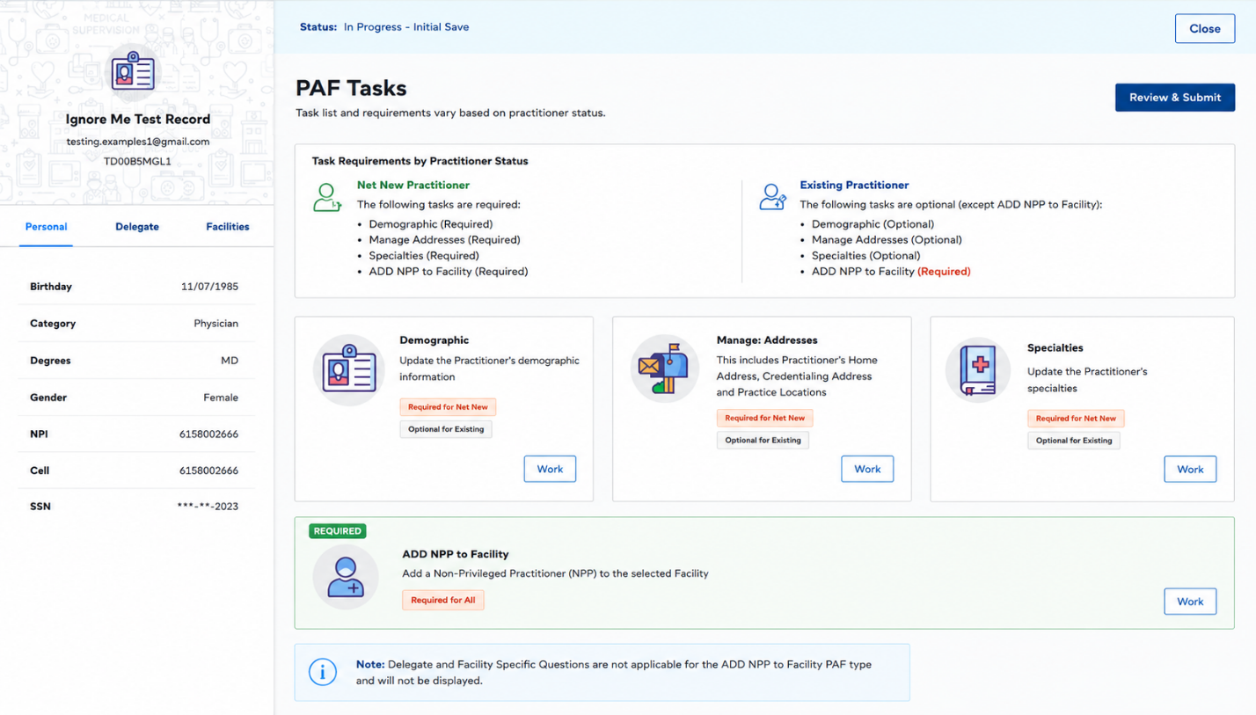
Summary
A new PAF task card will be created specifically for the ADD NPP to Facility workflow.
The task card will display within the PAF Tasks page and will function similarly to existing task cards currently utilized within the PAF workflow.
Requirements
- A new PAF task card labeled “ADD NPP to Facility” will be created.
- The card will display within the PAF Tasks section after practitioner initiation of the ADD NPP to Facility PAF Action.
- The card will follow the same UI styling, behavior, and interaction patterns as existing PAF task cards.
- The card will include:
- Task title
- Task description/instructions
- Required indicator
- Work button
- The “ADD NPP to Facility” task card will always display as Required regardless of practitioner type.
- Selecting the “Work” button will route the user to the ADD NPP to Facility workflow tasks and supporting questions.
- Only MSP users with access to the ADD NPP to Facility PAF Action will have visibility to this task card.
- Delegate card will be suppressed and should not display for the ADD NPP to Facility PAF Type.
- Facility Specific Questions card will be suppressed and should not display for the ADD NPP to Facility PAF Type.
- Task card requiredness for remaining cards will vary based on practitioner type:
- Net New Practitioner - The following task cards will display as Required:
- Demographic
- Manage Addresses
- Specialties
- ADD NPP to Facility
- Existing Practitioner - The following task cards will display as Optional:
- Demographic
- Manage Addresses
- Specialties
- The following task card will remain Required:
- ADD NPP to Facility
UI Display Requirements
- Card Title
- ADD NPP to Facility
- Card Description
- Upload and complete required Non-Privileged Practitioner (NPP) verification information and supporting PSV documentation.
- Status Indicator
- Required
- Action Button
- Work
UI Behavior
Action | Expected Result
User selects “Work” | Opens ADD NPP to Facility workflow
User completes required workflow items | Task card status updates accordingly
Required items incomplete | Review & Submit remains unavailable
Mockup
The ADD NPP to Facility card should visually align with existing PAF task cards currently displayed within the PAF Tasks page.
Recommended placement:
- Display directly beneath existing task cards or in the next available task card position within the grid layout.
Recommended styling:
- Utilize same icon sizing and spacing as existing task cards.
- Utilize Required status badge.
- Utilize existing “Work” button styling and interaction behavior.
No Impact
- Existing PAF task cards
- Existing task routing logic
- Existing practitioner demographic workflows
- Existing packet workflows unless otherwise specified

Demographic Card
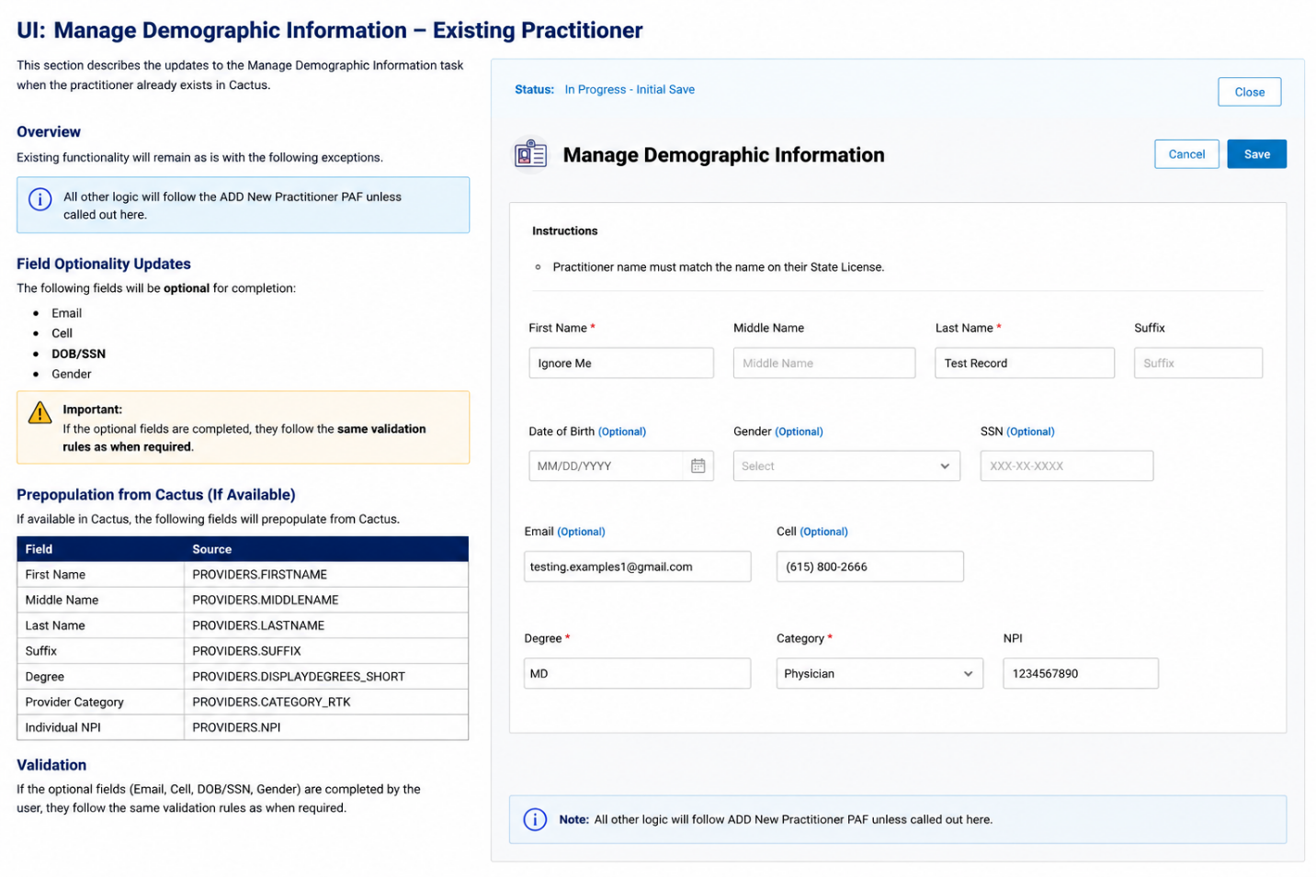
Requirements
- Existing functionality will remain as is with the following exceptions:
- The following fields will be optional for completion:
- Email
- Cell
- DOB/SSN
- Gender
- If available in Cactus, the following will prepopulate from Cactus:
Field | Source
First Name | PROVIDERS.FIRSTNAME
Middle Name | PROVIDERS.MIDDLENAME
Last Name | PROVIDERS.LASTNAME
Suffix | PROVIDERS.SUFFIX
Degree | PROVIDERS.DISPLAYDEGREES_SHORT
Provider Category | PROVIDERS.CATEGORY_RTK
Individual NPI | PROVIDERS.NPI

- Validation Rule for Optional Fields
- If any of the optional fields listed above are completed, they must follow the same validation rules as when those fields are required.
- Additional Logic
- All other logic will follow the ADD New Practitioner PAF unless called out here.

Manage Addresses Card (UI)
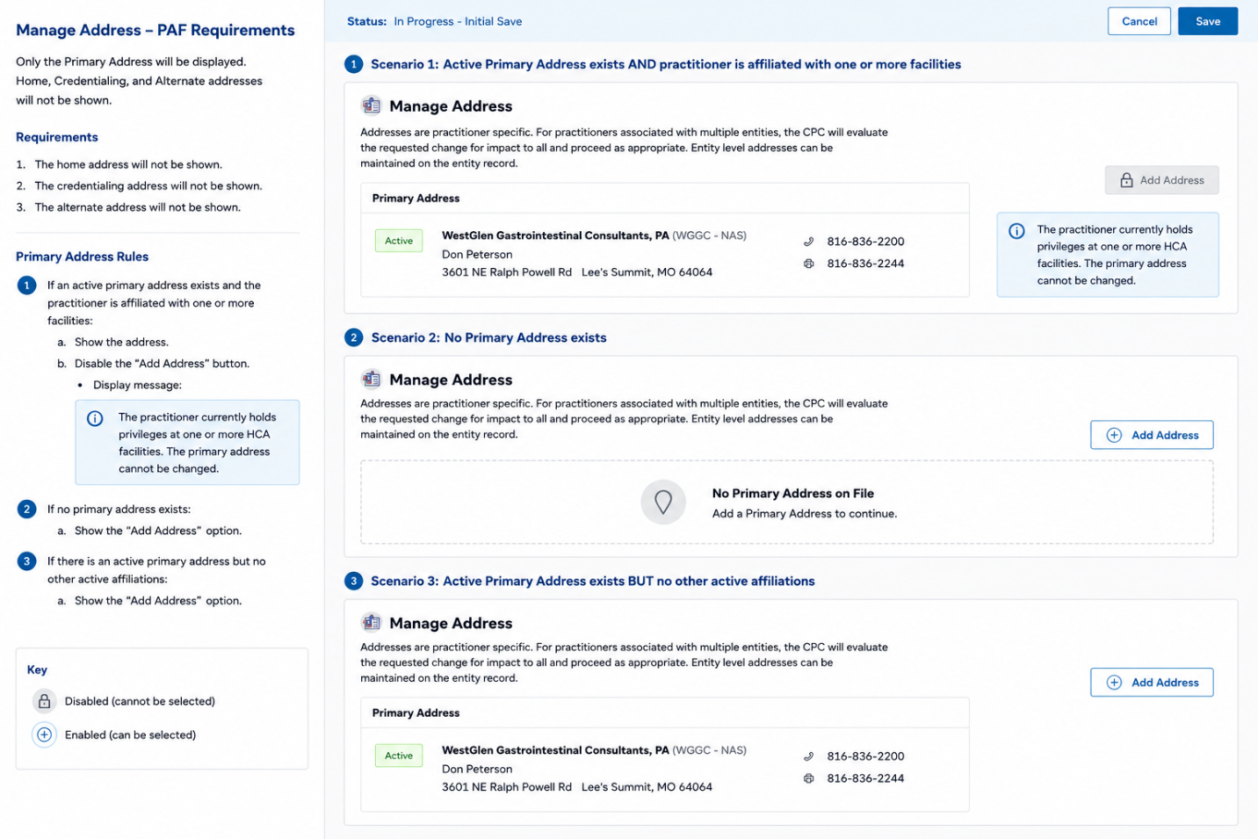
Requirements
- The home address will not be shown.
- The credentialing address will not be shown.
- The alternate address will not be shown.

Primary Address (UI)
- If an active primary address exists and the practitioner is affiliated with one or more facilities:
- Show the address.
- Disable the “add address” button.
- Display message:
- “The practitioner currently holds privileges at one or more HCA facilities. The primary address cannot be changed.”
- If no primary address exists:
- Show the “add address” option.
- If there is an active primary address but no other active affiliations:
- Show the “add address” option.

Manage Address
- When user selects “Add Address”
- Suppress the following prompt from displaying:
- Note: Group addresses will not be available for selection in this specific PAF type.

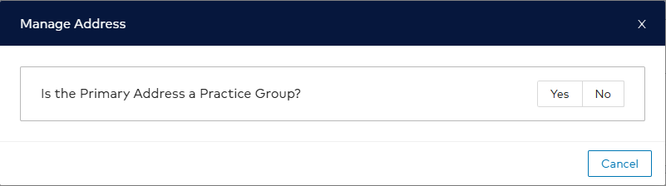

Add Address
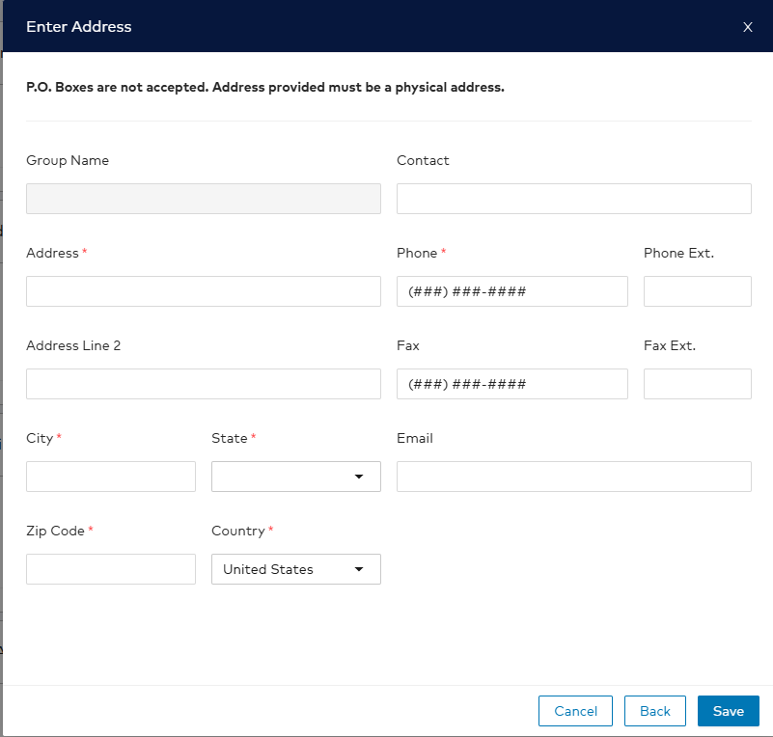
- User will be prompted to complete the following:
Field | Requirement
Contact | Optional, Character 60
Address | Required, Character 50
Address Line 2 | Not Required, Character 50
City | Required, Character 40
State | Required, Dropdown
Zip Code | Required, Character 11
Country | Required, Dropdown
Phone | Required, (nnn)nnn-nnnn
Phone Extension | Not Required, Character 10
Fax | Required, (nnn)nnn-nnnn
Fax Extension | Not Required, Character 10
- Validation errors will display in same fashion as ADD Practitioner to Facility PAF type.

Specialties Card
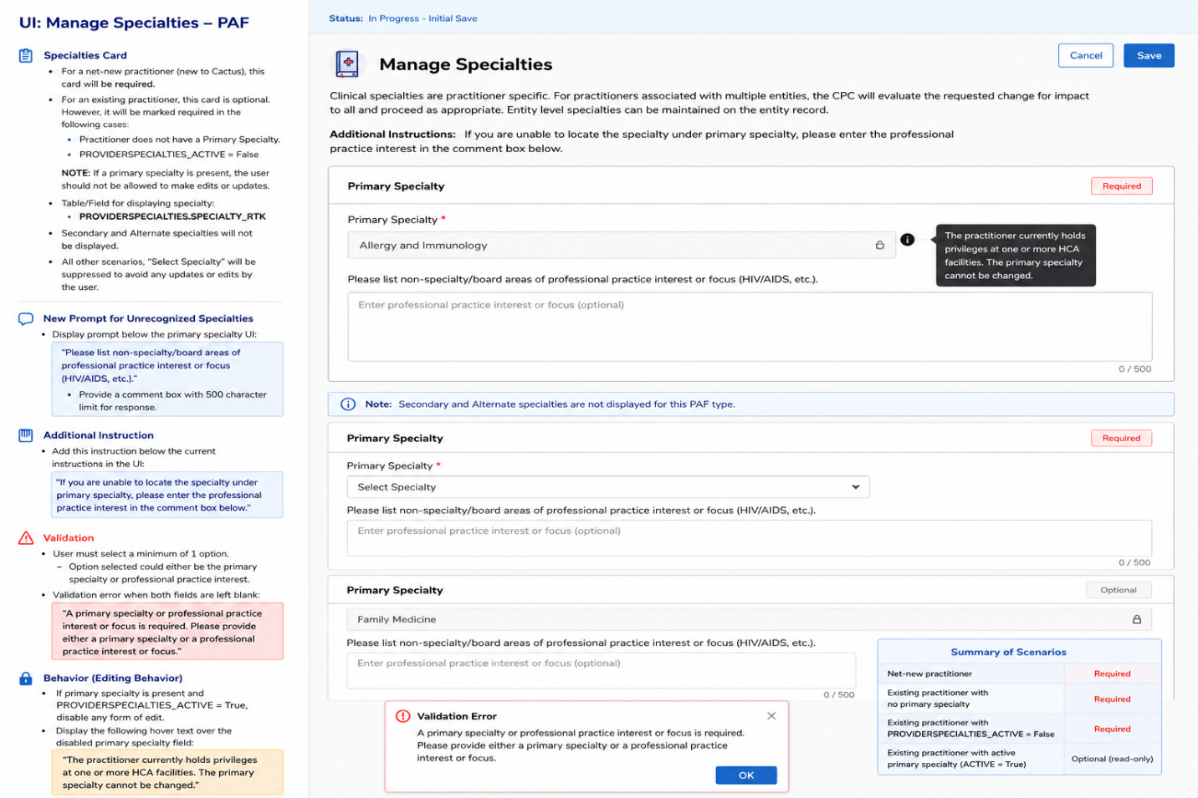
- For a net-new practitioner (new to Cactus), this card will be required.
- For an existing practitioner, this card will be optional. However, in the following cases it will be marked required:
- Practitioner does not have a Primary Specialty.
- PROVIDERSPECIALTIES_ ACTIVE=False
NOTE: If a primary specialty is present, the user should not be allowed to make edits or updates.
- Table/Field for displaying specialty:
- PROVIDERSPECIALTIES.SPECIALTY_RTK
- Secondary and Alternate specialties will not be displayed.
- All other scenarios with the exception of those listed above, “Select Specialty” will be suppressed to avoid any updates or edits by the user.

New Prompt for Unrecognized Specialties
- Create a new Prompt for unrecognized specialties Display prompt:
- “Please list non-specialty/board areas of professional practice interest or focus (HIV/AIDS, etc.).”
- Provide a comment box with 500 character limit for response.
- Explanation will be positioned directly below the primary specialty UI.
- Add Additional Instructions directly below current set of instructions in the UI
- “If you are unable to locate the specialty under primary specialty, please enter the professional practice interest in the comment box below.”

Validation
- User must select a minimum of 1 option.
- Option selected could either be the primary specialty or professional practice interest.
- Validation error pop up when both fields are left blank:
- “A primary specialty or professional practice interest or focus is required. Please provide either a primary specialty or a professional practice interest or focus.”

Behavior
- If primary specialty is present and PROVIDERSPECIALTIES_ACTIVE = True, disable any form of edit.
- Display the following hover text over the disabled primary specialty field:
- The practitioner currently holds privileges at one or more HCA facilities. The primary specialty cannot be changed.

Cactus Updates – Specialties

Existing “Active” Practitioner
- No updates unless a Primary Specialty record does not exist.

Net New or Inactive Practitioner
If Primary Specialty entered on PAF:
Field | Update
PROVIDERSPECIALTIES.Specialty_RTK | Set to RTK value of first specialty selected on PAF
PROVIDERSPECIALTIES.SpecialtyType_RTK | Set to Primary PRSPTYPRIM
PROVIDERSPECIALTIES.Active | Set to Active
If Professional Practice Interest (PPI):
- Set specialty record with value of APP-Other.
- Set Status = “Not Certified”.

Building – ADD NPP to Facility Card
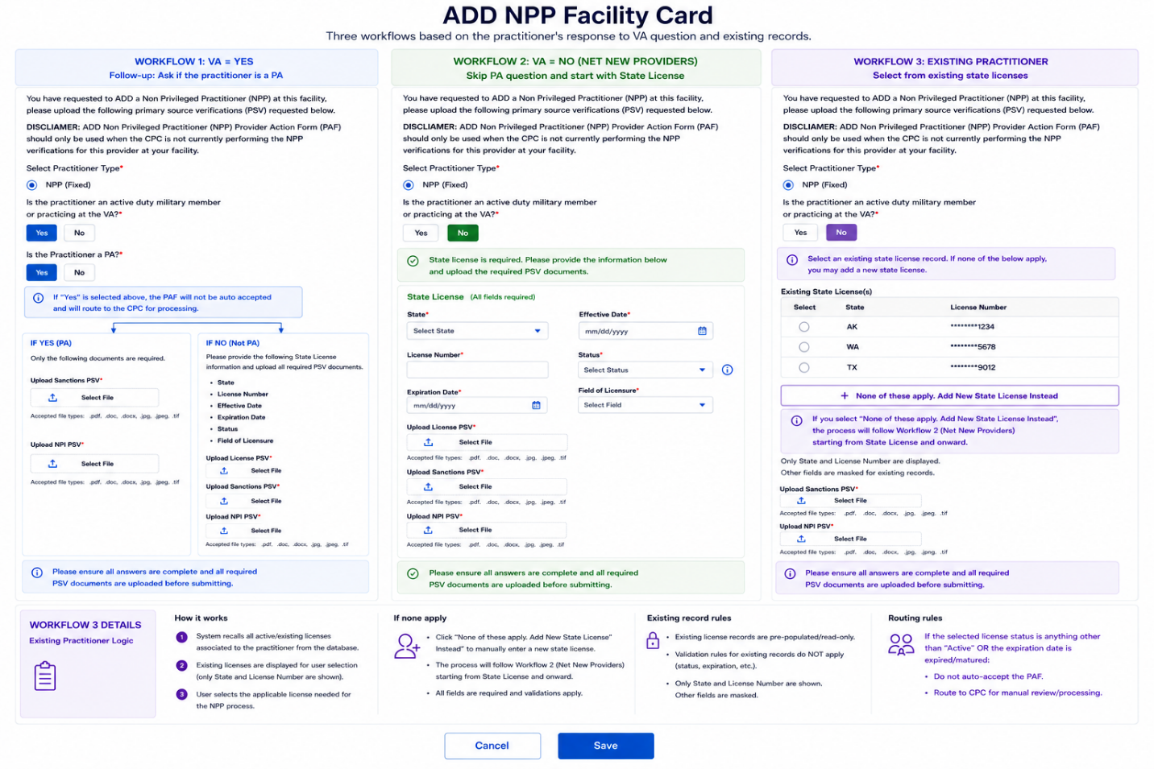

New Facility Card
- A new facility card will be created:
- ADD NPP to Facility
- Verbiage
“You have requested to ADD a Non Privileged Practitioner (NPP) at this facility, please upload the following primary source verifications (PSV) requested below.”
“DISCLAIMER: ADD Non Privileged Practitioner (NPP) Provider Action Form (PAF) should only be used when the CPC is not currently performing the NPP verifications for this provider at your facility.”
- Select Practitioner Type
- Add “Select Practitioner Type”.
- Practitioner Type = NPP.
- User can select only one option.
- Practitioner Type is fixed to NPP only.
- Field is required.
- Validation message:
- “This field is required.”
- VA Question Workflow Logic
Question: “Is the practitioner an active duty military member or practicing at the VA?”
- Display Yes and No radio buttons.
- If YES is selected, display follow-up PA question.
- If NO is selected, hide PA question and display State License section.
- Follow-up Question
- “Is the Practitioner a PA?”
- Display Yes and No radio buttons.
- User can select only one option.
- Field is required.
- Validation message: “This field is required.”
- Exception
- If YES is selected for PA question:
- PAF will auto accept.
- Route to CPC for processing.
- Create CVI

Workflow 1 – VA = YES
- If PA = YES
- Hide State License section.
- Require Upload Sanctions PSV.
- Require Upload NPI PSV.
- Route PAF to CPC.
- PAF will not auto accept.
- If PA = NO
- Display State License section.
- Require all State License fields.
- Date must be equal to or greater than today
- Validation Message: Date must be greater than or equal to today
- Require Upload License PSV.
- Require Upload Sanctions PSV.
- Require Upload NPI PSV.

Workflow 2 – VA = NO (Net New Providers)
- Skip the PA question entirely.
- Automatically display the State License section.
- Workflow begins with State License and onward.
- Require all State License fields.
- Date must be equal to or greater than today
- Validation Message: Date must be greater than or equal to today
- Require Upload License PSV.
- Require Upload Sanctions PSV.
- Require Upload NPI PSV.

Workflow 3 – Existing Practitioner
- Recall all active/existing licenses associated to the practitioner from the database.
- Display recalled licenses for user selection.
- Display the following fields in the UI:
- State
- License Number
- Expiration Date
- Display button/link:
- “None of these apply. Add New State License Instead.”
- If user selects “Add New State License Instead”:
- Follow Workflow 2 beginning with State License and onward.
- Additional Rules:
- Existing practitioner records bypass standard validation rules.
- If selected license status is not Active OR expiration date is expired/matured, route to CPC.
  - Route the request to CPC for manual review.
  - Display the following informational message to the user: "You have selected a license that is either inactive or expired and will require review by the CPC. Once the CPC has reviewed the license, it will be updated accordingly. Please do not add another license."
- When a user elects to add a new license, the system shall compare the entered State and License Number against the licenses displayed in the Existing Practitioner license list.
- If the entered State and License Number match an existing license already presented in the UI, the system shall:
- Prevent creation of a new license record.
- Display the following message: "A license with this State and License Number already exists for this practitioner. Please select the existing license record displayed above."
- Return the user to the existing license selection list.
- The system shall not allow duplicate licenses with the same State and License Number to be created for a practitioner.
License State Validation
For Workflow #2 and #3, add a validation check to ensure that providers submitted for entities located in CA, LA, NV, KY, and TX hold a professional license that matches the state of the entity location. For example, if the entity is located in TX, the provider must have a TX license. If the provider does not hold the required state license, the PAF cannot be submitted.
Error Message
If the license does not match the entity state, MSP must receive the following error message:
“A state license in the state of ‘XX’ is required for PAF submission.”

State License Requirements
Field | Requirement
State | Required, Dropdown, Character Limit = 2
Effective Date | Required, MM/DD/YYYY
License Number | Required, Character Limit = 20
Status | STATUS_RTK values only
Expiration Date | Required, MM/DD/YYYY
Field of Licensure | Required ****
**** FOL selection***
- STATUS_RTK Values
- Active = DRFB0IQ54S
- Temporary Permit = D2H11CCT3V
- Active Military = D3UK1E0UF6
- Active-Compact = M5890K2GGY
- Hover text for Active Military:
- “Use this type for civilian practitioners working for the VA.”

Upload License PSV Requirements
- Upload License PSV is required.
- Accepted file types:
- DOC
- DOCX
- PDF
- JPG
- TIFF
- Display validation error for unsupported file types.
- Must be added to Cactus in PDF format (HTML).
- Attach to State License record.
- Insert value from HCO.Cactus Image ParentFile.
- Image Name = Images.Description.
- Insert value from HCO.Cactus Image Name.
- MMDDYY represents date PAF was submitted.
- Type = Images.Type_RTK value.
- Insert value from HCO.Cactus Image Type.
- Publish on Web = T.
- Images.publishonweb = T.
- Images.Active Set = T.
- Images.AsOfDate = Date PAF Auto Accepted by CPC.
- As Of Date format = MMDDYY.
- Audit log all image entries in Cactus.
- Use "HCP System User - MSP submitter Name" for User.
- Use "HCA Corporate" for Entity.
- RTK values for State = NPDBSTATEx

Routing Rules
- If PA = YES, PAF routes to CPC.
- If license status is not Active, route to CPC.
- If expiration date is expired/matured, route to CPC.
- Net new licenses must follow all validation rules.
- Existing practitioner recalled records bypass standard validation rules.

CVI Creation
When a workflow specifies "Route to CPC" or references "CPC Processing" (including, but not limited to, Military PA, NP, Resident, missing credential, inactive license, or expired license), the system shall perform the following actions:
- Upon PAF submission, the PAF shall be automatically accepted.
- The MSP user shall be presented with the following informational message:
"This PAF requires manual processing by the CPC due to a missing or expired credential."
- The system shall automatically create a CVI with the following attributes:
Field | Value
CVI Type | Facility Undefined Practitioner
Initial Status | UDP Facility Request
Available Closure Status | UDP Facility Request Complete
Started Date | Date and time of PAF auto acceptance
Received Date | Date and time of PAF auto acceptance
CVI Notes | The specific PAF criteria that triggered CPC Processing
MSO Due Date | Date of PAF auto acceptance plus three (3) business days
CVI Group Name | NPP Date of PAF Auto Acceptance
- The CVI shall remain in UDP Facility Request status until CPC processing is completed.
- Upon completion of CPC processing activities, the CVI shall be updated to UDP Facility Request Complete status.
- Any PAF submitted through a CPC Processing workflow shall have the associated PAF PDF attached to the created CVI rather than the Provider Record.

Cactus Updates – NPP Card – State License
- Existing Records
- Prepopulated state license will not be updated when the PAF is accepted when practitioner is active at another facility.
- Exception: If practitioner is existing and currently inactive: Follow same guidelines for Net New practitioner.
- New Records
- If practitioner user adds a new state license record:
- System will add a new state license record when the PAF is accepted.
- System will perform duplicate check prior to adding new record.
- Additional Cactus Updates:
- PersistentVerification = T
- Type_RTK = NPDSTATEx
- NPDBPrimaryLicense = T
- LICENSE_RTK = State License
- LICENSENUMBER = Number keyed on PAF
- AWARDEDDATE = Date entered on PAF
- EXPIRATIONDATE = Date entered on PAF
- LICENSUREFIELD_RTK = Long Description entered on PAF
- LICMONENROLLMENTSTATUS_RTK = Requesting – Ready to enroll in LEMM

Auto-Acceptance of ADD NPP
- The CPC does not need to review or approve the ADD NPP PAF after it has been submitted by the user unless noted above.
- We will use the “Auto-Acceptance” feature.
- “Auto-Accepted” PAF Types will route to the PAFs Completed Queue once the Cactus updates have been completed.
- Completed PAFs History will input “HCP System User” as the User Name in the Auto-Accepted PAF Details.
- Cactus Audit Log for all Cactus Updates (for Auto-Accepted PAFs) will be written with “HCP System User – MSP submitter name” for the User and “HCA Corporate” for the Entity.
- The PAF PDF shall be uploaded to the Provider Record unless the submission meets criteria that result in the creation of a CVI. If a CVI is created, the PAF PDF shall be attached to the corresponding CVI instead of the Provider Record.

ADD NPP PAF Form & PDF Changes
- The PDF will display “ADD NPP to Facility” for the Type.
- PDF History will input “HCP System User – MSP submitter name” as the User Name in the Auto-Accepted PAF Details.

Building – Cactus Records

Provider Record
- Provider Record – New to Cactus
Field | Source
First Name | PROVIDERS.FIRSTNAME
Last Name | PROVIDERS.LASTNAME
Suffix | PROVIDERS.SUFFIX
Degree | PROVIDERS.DISPLAYDEGREES_SHORT
Provider Category | PROVIDERS.CATEGORY_RTK
Individual NPI | PROVIDERS.NPI
- Provider Record – Existing
- No changes.

Entity Assignment Record
- Entity Assignment record for a net new practitioner will be built with existing logic and requirements unless otherwise noted.
- Record security shall be set to Internal Use Only unless the NPP has had existing privileges at the entity listed on PAF.
- Definition of existing privileges is an inactive entity that has a start and end date. We will leave those as is.
- Status will be set to “NPP – Active” if a Status is not currently set.
Note: This is the Entity Assignment record for the facility that the MSP selected on PAF
- STATUS_RTK
- ENTITYASSIGNMENTS M67G0Q3AIP
- RTK = “NPP-Active”
- If Status is anything other than those listed below, do not update
- None or N/A
- NPP – Inactive
- NPP – Suspend
- Inactive

Provider Address Record in Cactus Based on Data Entered on the PAF
- No Existing Record -Add record using data from PAF.
Field on PAF | Cactus Table | Cactus Field
Primary Address | PROVIDERADDRESSES | ADDRESSTYPE_RTK
Address Line 1 | ADDRESSES | ADDRESSLINE1
Address Line 2 | ADDRESSES | ADDRESSLINE2
City | ADDRESSES | CITY
State | ADDRESSES | STATE
Zip | ADDRESSES | ZIPCODE
Country | ADDRESSES | COUNTRY
Phone # | ADDRESSES | PHONE
Phone Extension | ADDRESSES | EXTENSION
Fax # | ADDRESSES | FAX
Fax Extension | ADDRESSES | FAXEXTENSION
Email | ADDRESSES | EMAIL
- Existing Record
- No changes.

Specialties
- Existing “Active” Practitioner – No updates unless a Primary Specialty record does not exist
- Net New or Inactive Practitioner
- Primary Specialty Entered on PAF, add the Provider Specialty Record:
- Specialty: PROVIDERSPECIALTIES.Specialty_RTK, set to RTK value of the first specialty selected on PAF
- Specialty Type: PROVIDERSPECIALTIES.SpeciatlyType_RTK, Set to Primary PRSPTYPRIM
- Specialty Active: PROVIDERSPECIALTIES.Active, Set to Active
- If the selection on the PAF is instead Professional practice Interest (PPI)
- Set specialty record with value of APP-Other
- Set Status = “Not Certified” PROVIDERSPECIALTIES. SPECIALTYSTATUS_RTK DS9Q12M4UO

State License
- Check for existing records based on:
- License Type (State)
- License Number
- License State
- Existing Records:
- Prepopulated state license will not be updated when the PAF is accepted.
- New Records:
- If MSP user adds a new state license record, system will add a new state license record when the PAF is accepted.
- New Record Requirements
- PersistentVerification = T
- Type_RTK = NPDSTATEx
- NPDBPrimaryLicense = T
- LICENSE_RTK = State License
- LICENSENUMBER = Number keyed on PAF
- AWARDEDDATE = Date entered on PAF
- EXPIRATIONDATE = Date entered on PAF
- LICENSUREFIELD_RTK = Long Description entered on PAF
- LICMONENROLLMENTSTATUS_RTK = Requesting – Ready to enroll in LEMM
- Attach License Image
- Image Name:
- First 13 Letters of Last Name_First 3 Letters of First Name_XX(State)_Lic_MMDDYY
- Image Type:
- Medical License
- Image Notes:
- Uploaded via auto PAF for ADD NPP to Facility

NPI
- Attach license image to Provider Record.
- Image Name:
- First 13 Letters of Last Name_First 3 Letters of First Name_NPI_MMDDYY
- Image Type:
- NPI
- Image Notes:
- Uploaded via auto PAF for ADD NPP to Facility

Sanctions
- Check for existing “Sanction Check” record based on LICENSE_RTK.PROVIDERLICENSES S3PK02GTA1.
- If there is currently not a “Sanction Check” record in CACTUS, create record.
- Attach “Sanctions” image from PAF to corresponding record.
Image Requirements
- Image Name:
- First 13 Letters of Last Name_First 3 Letters of First Name_Sanctions_MMDDYY
- Image Type:
- Sanction Checks
- Image Notes:
- Uploaded via auto PAF for ADD NPP to Facility

Scripts
The business has requested that a script be executed within the credentialing database to automatically close CVIs that meet the following criteria:
CVI Status = UDP Facility Request Complete
The purpose of this request is to ensure that all CVIs in the "UDP Facility Request Complete" status are systematically closed, reducing manual intervention and maintaining data accuracy and consistency within the credentialing system.

Reports
The business requires a monthly report to be generated and distributed at the beginning of each month. The report should be sent to the Reporting Team and the CPC Distribution List.
The report must include the following metrics for the previous reporting period:
- Total number of Add NPP requests received.
- Total number of Add NPP requests routed to CPC.
- Percentage of received Add NPP requests that were routed to CPC (if applicable).
The report should provide a summary of activity for the reporting period and support business oversight and operational tracking of Add NPP request processing.

Reporting Team
MOR Reporting Exclusion Requirement
CVI records with a CVI Type = Facility Undefined Practitioner shall be excluded from MOR (Monthly Operations Report) statistical calculations and reporting metrics.
The exclusion applies to all MOR reporting outputs where CVI counts STAT metrics are reported.

